Hi [Jane Doe]:
Want to help a local nonprofit in need? Please keep ABC Nonprofit in mind on your special day – your birthday!
Nonprofit organizations need your help now more than ever amidst the COVID-19 pandemic. Please consider supporting ABC by hosting a Facebook fundraiser during your birthday – it would mean the world to the people [animals] that rely on ABC Nonprofit’s services!
Did you know?
- If you raise $50 during your birthday fundraiser, ABC Nonprofit will be able to provide meals for 1 week for 5 of our students.
- If you raise $100 during your birthday fundraiser, ABC Nonprofit can provide bird food for our entire flock for 2 weeks.
- If you raise $200 during your birthday fundraiser, ABC Nonprofit can provide hand sanitizer for 50 of our at-risk staff members.
- If you raise $1,000 during your birthday fundraiser, ABC Nonprofit can look into the disappearance of Carole Baskin’s husband.
We won’t bore you with more examples, but we hope you get the point – a little bit goes a long way, especially during trying times.
So, how do you start a Facebook birthday fundraiser?
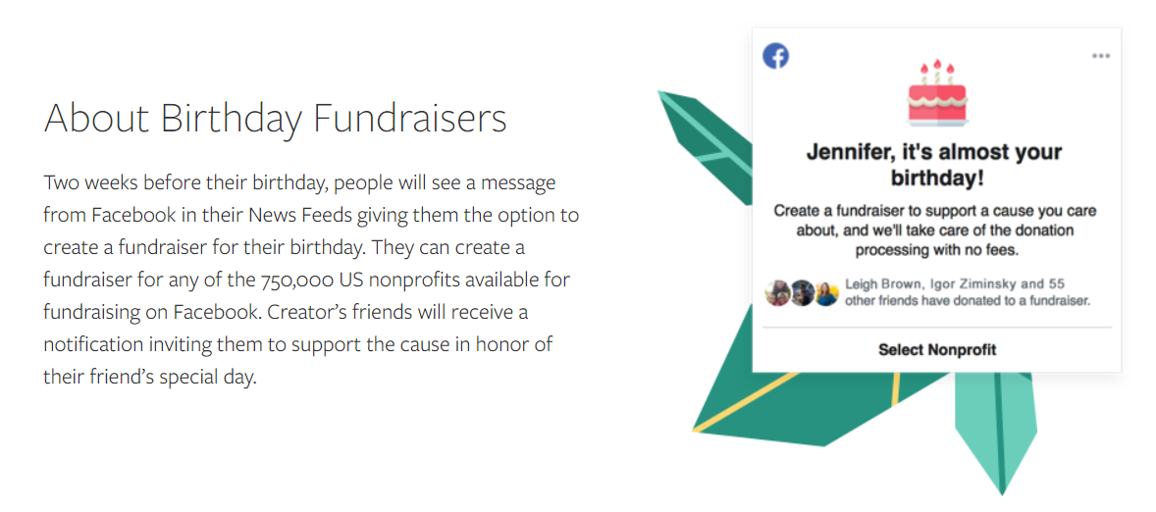
Source: https://socialgood.fb.com/charitable-giving/birthday-fundraiser/

Keep reading! →

The steps:
- Select the nonprofit you want your birthday fundraiser to benefit (we hope it’s us!)
  - Don’t see us on the list? Reach out and let us know [insert contact email link] – we’ve signed up for Facebook Fundraising, but there could have been a glitch!
[Not signed up for Facebook Fundraising? Access the “how-to” guide here.]
- Set a fundraising goal
  - Try to find a sweet spot for this. Are your Facebook friends more likely to give in short bursts, or do you think they’re typically larger gift-givers? It all depends (and all types of gifts are helpful). A $5,000 goal that raises $200 can appear a little sad
- Tell your story
  - Here is your time to shine! Have you worked with ABC Nonprofit before? Do you love our flock of birds or did ABC’s Janet in the Student Division really change your kiddo’s reading trajectory? Let your followers know! This is what will motivate your audience to support your birthday goals.
- Create a cover photo
  - Here is our pre-made template [make your own for FREE with Canva for Nonprofits & learn more about Canva]:
  - OR feel free to make your own! We made ours via Canva – get your free account today and start creating.
- Invite your friends
  - Please
- Consider a match
  - A match can spur giving. What does this mean? You would pledge to match up to $__ in donations. So, if $150 was raised, and you had pledged to match up to $50, you would throw in $50 to the cause at the end of the fundraiser, for a total of $200 for ABC Nonprofit. That would be SO cool!
- Watch the generosity unfold
  - Follow some of the tips below and let the magic happen. Thank you!
Tips:
- Sometimes people are strapped for cash but they still want to help. Give them another option! Make sure to include a push for sharing your fundraiser – maybe their share will get your fundraiser in front of an interested audience member you wouldn’t have accessed otherwise. That’s a donation in itself.
- Send/post a few reminders. People are busy and newsfeeds are clogged (especially now!).
- Don’t forget the thank you! This is one of the most important parts of fundraising
- Getting stir crazy while social distancing? Kick the birthday fundraiser up a notch – add challenges! Example: If $200 is raised during my birthday fundraiser, I will dye my hair BLUE! If $500 is raised during my birthday fundraiser, I will dress my dog as a tiger and pretend to be Joe Exotic via Facebook Live! Etc.

Additional information:
- An organization's location and enrollment status determine how donations made through Facebook are paid out. Facebook covers payment processing fees so that 100% of donations made on Facebook are distributed to the organization. Source: https://www.facebook.com/help/1894431287460580?helpref=related&source_cms_id=1251484118194936
  - Not many donation platforms cover payment processing fees – this is an awesome feature through Facebook! Another incentive for giving.
- After someone donates, that donor’s name, the host’s name, and the contribution amount will be shared with the nonprofit. Source: https://www.wholewhale.com/tips/facebook-birthday-fundraisers/
- Not your birthday season but you want to fundraise for ABC Nonprofit, anyways? WOW! We are flattered! Facebook has an option for this, too. Learn more now: https://www.facebook.com/fundraisers/ and contact us [insert link] if you need help!

